



JAVA PROGRAMMING
(340)
NATIONAL 2024

PRODUCTION:
Java_National ___________ (460 points)

Test Time: 90 minutes
Java_National

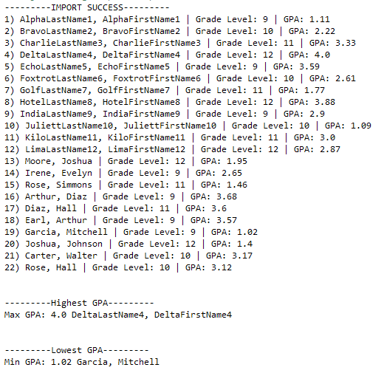
In this test you will be creating another prototype seating chart software for your local school. The program will be designed to import, read, and create student records based upon two different types of text files. One text file will be a list of names only, that the program will create random student records similar to the Java_State contest. The second file will be complete student records that the program must use to create student records. All records should be stored into one data structure. The other action you must take will be designing the program to sort the records in ascending (low to high) and descending (high to low) order based upon the GPA and the last names. All of the outputs will be automatic.

Output 1 General List: This output imports the NationalTestRecords and then imports the NationalStudentNames. After creating the records, the program will discover which record contains the highest and lowest GPA (see image on the right).

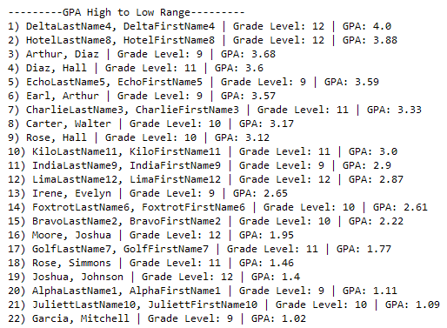
Output 2 GPA High to Low Range: The student records will be sorted from greatest to least (see image to the left).

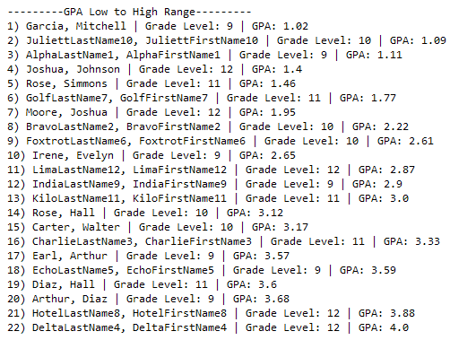
Output 3 GPA Low to High Range: The student records will be sorted from least to greatest (see image to the right).

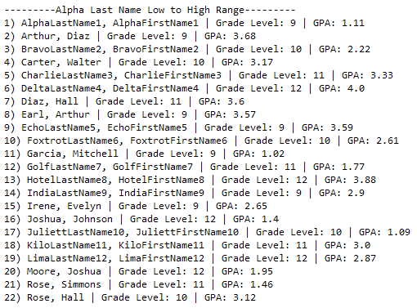
Output 4 Alpha Last Name Low to High Range: The student records will be sorted from least to greatest (see image to the left).

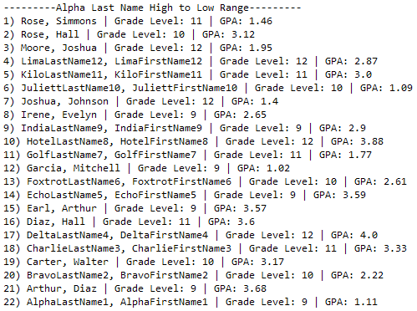
Output 5 Alpha Last Name High to Low Range: The student records will be sorted from greatest to least (see image to the right).

File Read Error (NationalTestRecords.txt): If the NationalTestRecords.txt is not found, the following message should appear and program exits.

File Read Error (NationalStudentNames.txt): If the NationalStudentNames.txt is not found, the following message should appear and program exits.

Solution and Project (There is NO partial credit) (NOTE: UC represents uppercase and LC represents lowercase)
The Java source file is present on the flash drive in a single folder with your contest ID |  | 10 points
Program Execution (If the program does not execute, then the remaining items in this section receive a score of zero)
Output 1 General List displays: first 12 records are from NationalTestRecords, last 10 are random from NationalStudentNames |  | 20 points
Output 1 General List displays correct Max GPA record and Min GPA record |  | 10 points
Output 2 GPA High to Low Range arranges all 22 records in proper order |  | 10 points
Output 3 GPA Low to High Range arranges all 22 records in proper order |  | 10 points
Output 4 Alpha Last Name Low to High Range all 22 records in proper order |  | 10 points
Output 5 Alpha Last Name High to Low Range all 22 records in proper order |  | 10 points
File Read Error (NationalTestRecords.txt) prints to console when file is missing |  | 10 points
File Read Error (NationalStudentNames.txt) prints to console when file is missing |  | 10 points
Subtotal |  | /100 Points

Source Code Review (There is NO partial credit) NOTE: you must place the comment flag in front of the comment in your code in order to get credit. The comment flag will precede the explanation. For example, if the flag is SC1, your comment must read as “#SC1…” in front of the part of the code being reviewed. Code must work to get credit. There is no partial credit.

A comment containing the contestant number is present at the top of the SeatingChartBuilderNATL.java file |  | 10 points
SC1: SeatingChartBuilderNATL.java class: comment data structures declaration and assignment statement of information gathered from NationalTestRecords.txt. Explanation of why this was used is required. |  | 10 points
SC2: SeatingChartBuilderNATL.java class: comment data structures declaration and assignment statement of information gathered from NationalStudentNames.txt. Explanation of why this was used is required. |  | 10 points
SC3: SeatingChartBuilderNATL.java class: comment code with explanation of what file reading strategy was used for NationalTestRecords.txt |  | 20 points
SC4: SeatingChartBuilderNATL.java class readNationalTestRecords method: comment code with explanation of how this method was used to gather data from NationalTestRecords.txt |  | 20 points
SC5: SeatingChartBuilderNATL.java class readNationalTestRecords method: comment code with explanation of how delimiter (,) and numerical data (integers and doubles) was managed to gather data from NationalTestRecords.txt |  | 30 points
SC6: SeatingChartBuilderNATL.java class: comment code with explanation of how to handle NationalTestRecords.txt file NOT being found |  | 20 points
SC7: SeatingChartBuilderNATL.java class: comment code with explanation of what file reading strategy was used for NationalStudentNames.txt |  | 20 points
SC8: SeatingChartBuilderNATL.java class readNationalStudentNames method: comment code with explanation of how this method was used to gather data from NationalStudentNames.txt |  | 20 points
SC9: SeatingChartBuilderNATL.java class readNationalStudentNames method: comment code with explanation of how delimiter (,) and empty spaces were managed to gather data from NationalStudentNames.txt |  | 20 points
SC10: SeatingChartBuilderNATL.java class: comment code with explanation of how to handle NationalStudentNames.txt file NOT being found |  | 20 points
SC11: SeatingChartBuilderNATL.java class print_GPAHightoLow_Range: comment code showing method was used to sort GPA high to low |  | 10 points
SC12: SeatingChartBuilderNATL.java class print_GPALowtoHigh_Range: comment code showing method was used to sort GPA low to high |  | 10 points
SC13: SeatingChartBuilderNATL.java class print_AlphaLowtoHigh_Range: comment code showing method was used to sort last names low to high |  | 10 points
SC14: SeatingChartBuilderNATL.java class print_AlphaHightoLow_Range: comment code showing method was used to sort last names high to low |  | 10 points
Subtotal |  | /240 Points
Total Points |  | /340 Points

